- Objective
This is for Schenker ops to perform invoice collection from hospital on behalf of JnJ.

- System set up
  - New program to allow ops to upload the invoices given by JnJ.
  - New program to allow ops to enter invoice collection date.

- Sample of the invoice template from JnJ.

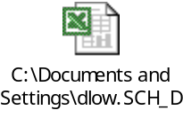

- IT enhancement man-days
  - It will take total of 3 days to include above enhancement in WSM

- Time Line
Production at : 1 Mar 2009
UAT : 28 Feb 2009

- End

